20th Jul 2022

Good Afternoon, Everyone!

Our Term 1 evening class will start next week.

**Not all classes will be conducted online** so please make sure you check your timetable via associate portal and select the correct semester to view your class venue for those having F2F classes.

**Please note that our seminars are recorded so please ensure you use and turn on your microphone in class.**

**For those teaching Online class via Zoom, please remember to setup your Zoom link and share it prior to class and also ensure session is recorded.**

**For instructors who will be teaching for the first time**, please do not hesitate to ask if you are unsure.

We will send out quite detailed instructions prior to assignment due dates so please make sure you read up the information given though they are lengthy - you will find most of your questions already addressed in the email.

Course Leaders, please send me your lesson plan if you have not done so.

**Please remind your own students to attempt their Pre-Course Quiz (PCOQ):**

Here is the Term1 PCOQ start date:

·       Monday 18July : ANL252/ ANL321

·       The following Monday 25Jul: ANL203 / ANL303 / ANL351

Here is the Term2 PCOQ start date:

·       Monday 5Sep : ANL312

·       The following Monday 12Sep: ANL305

Please login to your associate portal to check on the timetable and the venues (**for Full-time Faculty, please check via SIMS**).

If you are unsure on how to check the timetable, I have included a basic screenshot to guide you.

·       Timetable – you will be able to see the dates and also venue (should already be available today) - you will know if you will be teaching Online or F2F.

·       Class list – you will be able to see the list of students in your T-Group with all their essential contacts.

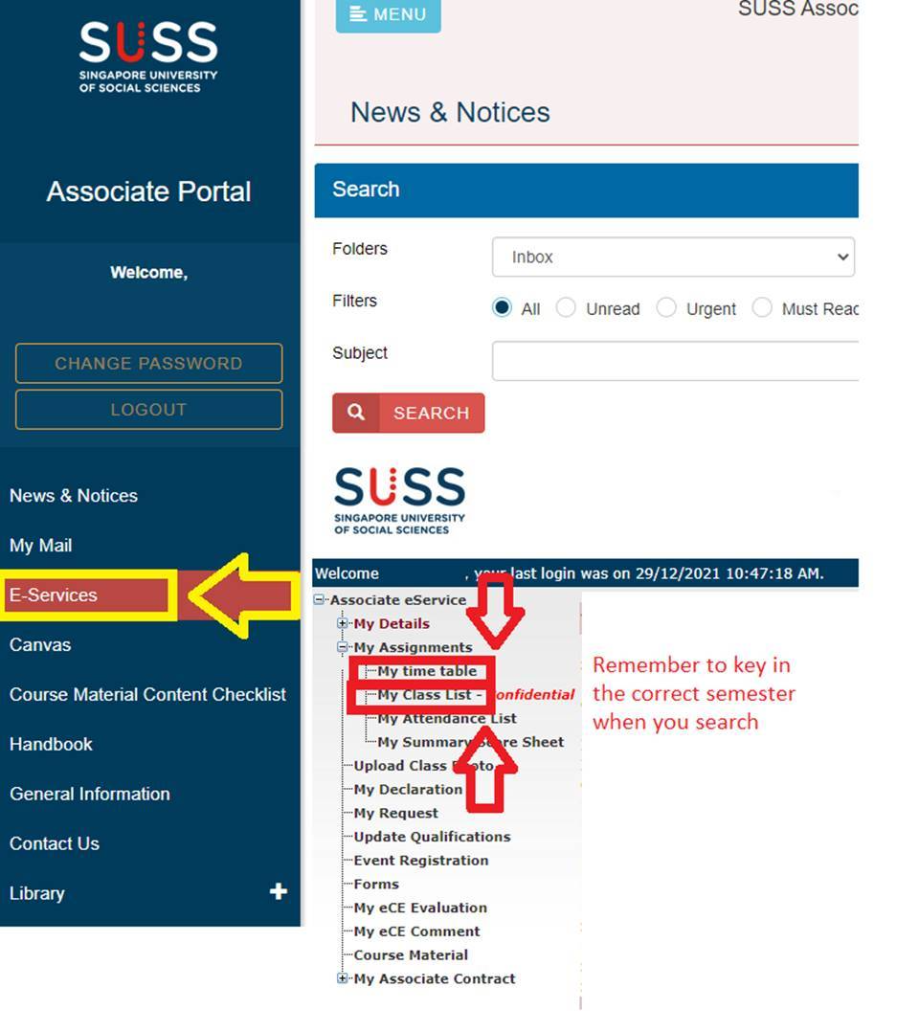

For those of you who taught last semester, please check your eCE results via your Associate Portal. Please note the feedback given and see what you can do to improve for your next round of teaching.

**If this is your first time teaching,** please familiarise yourself with the other services in the portal and also with Canvas as you will be using it extensively throughout your teaching semester. Please do not hesitate to consult your Course Leader / Course Coordinator.

If you are deployed as the Course Leader, please login to Canvas to ensure the Quiz questions are all in order and also your teaching materials ported over are still up-to-date.

In the event that you need to get in touch with SUSS personnel after office hours (from 5.30pm to 7.30pm) on matters regarding late arrival or cancellation of class on a particular day, they should contact the Resource & Scheduling (LS) department at 62489799. RS department will then make the necessary follow-up arrangements and notify the affected students.

Associates should NOT call 62489111 as there would be no logistical or scheduling support available to them.

Thank you.